Ticketing App on Spring MVC

Objective
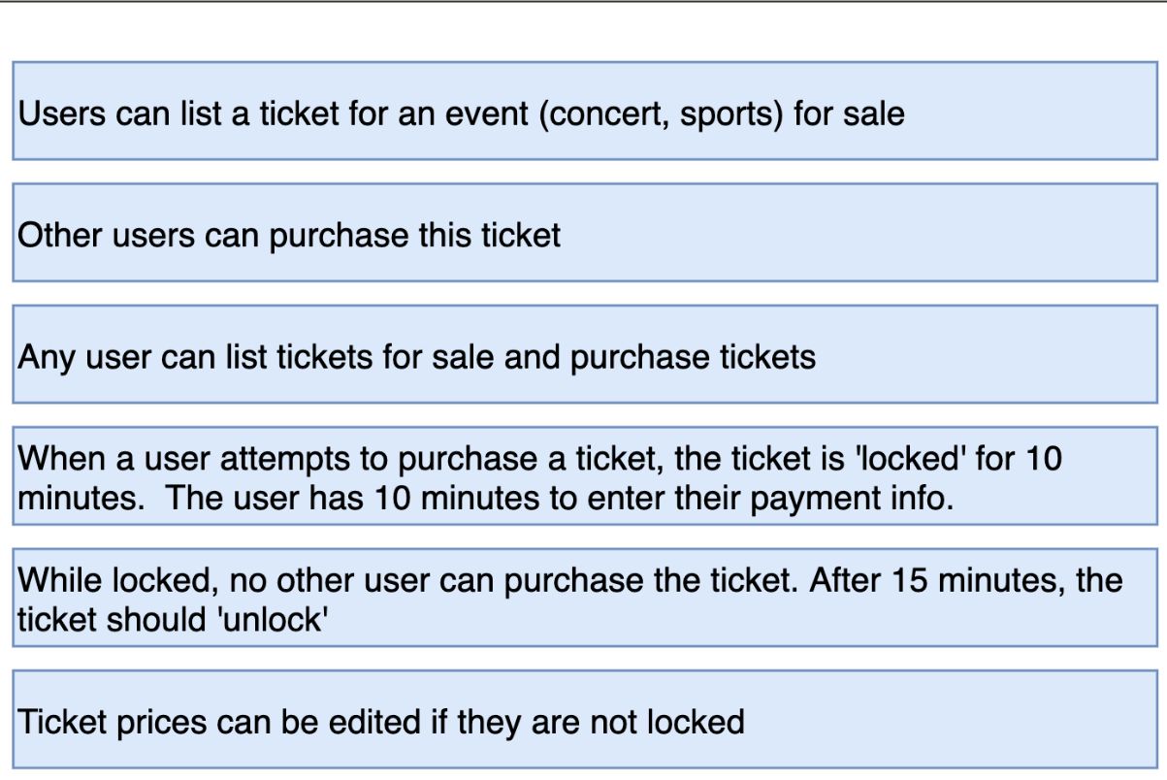

Reference : https://www.stubhub.com/

Spring Web MVC screens

Ticketing App 1

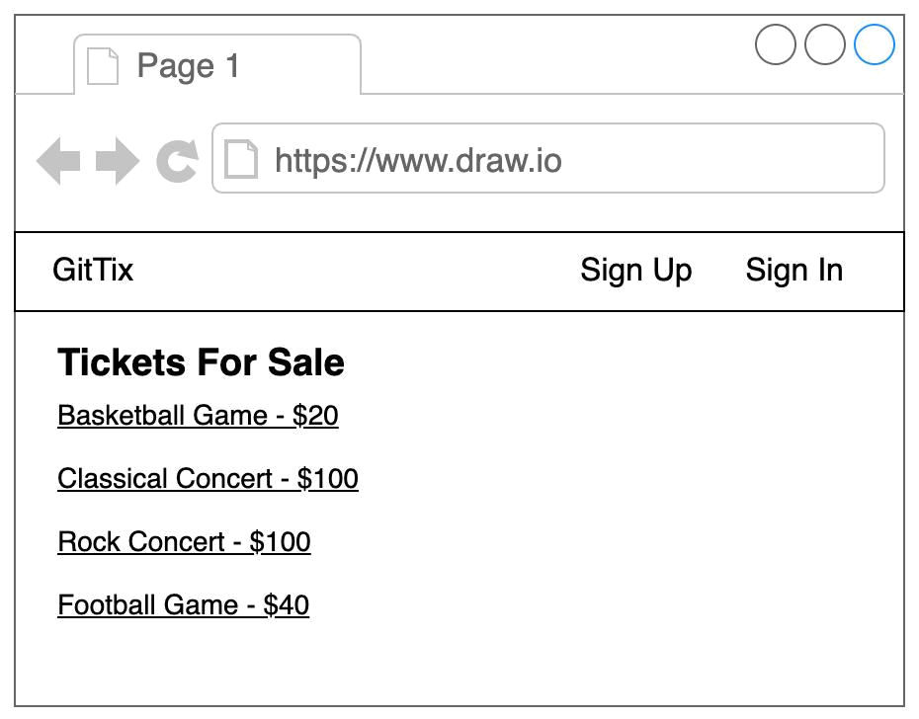

Ticketing App | 2

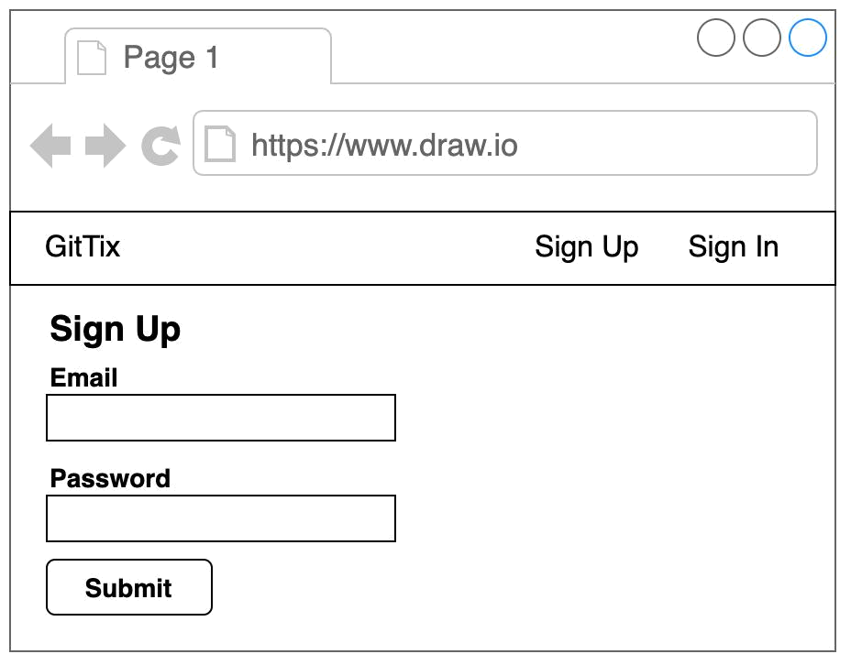

Ticketing App | 3

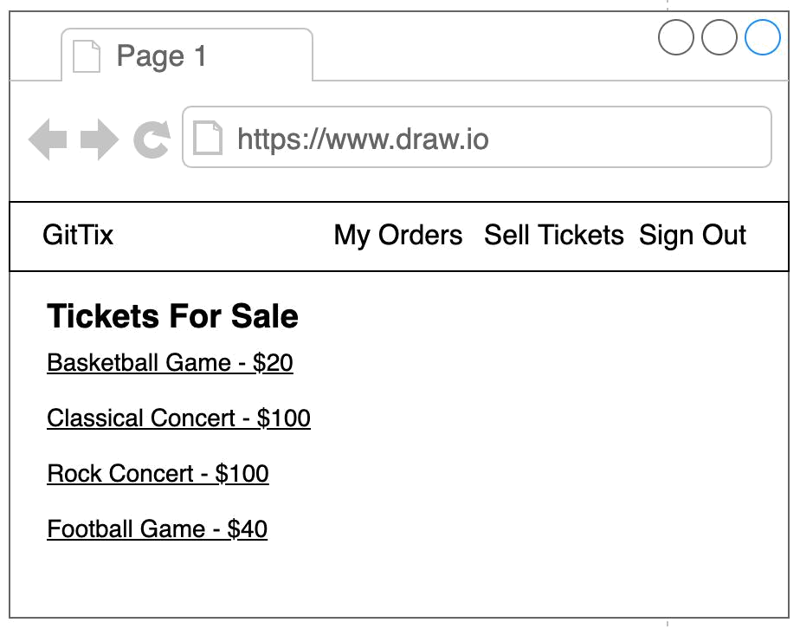

Ticketing App | 4

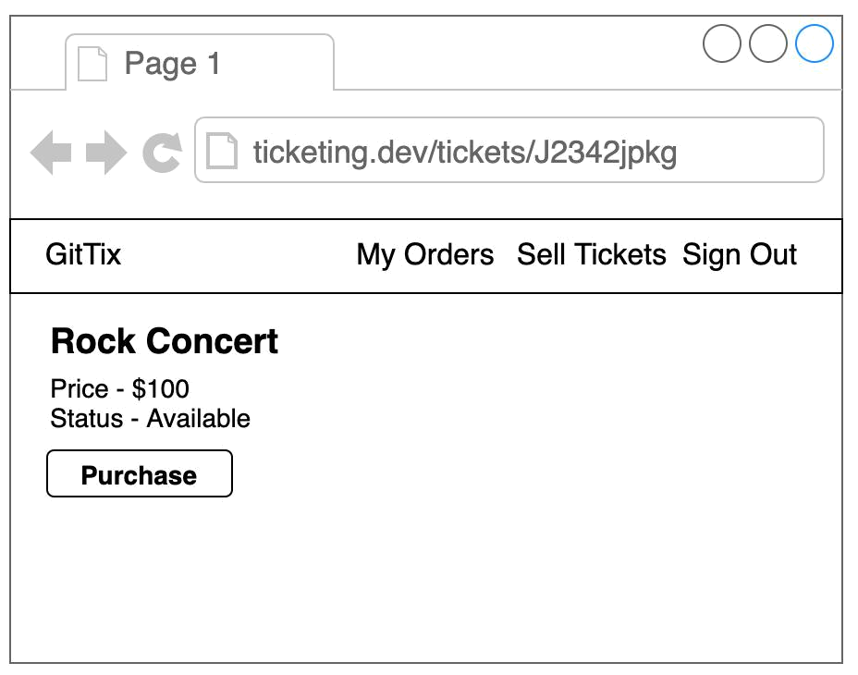

Ticketing App | 5

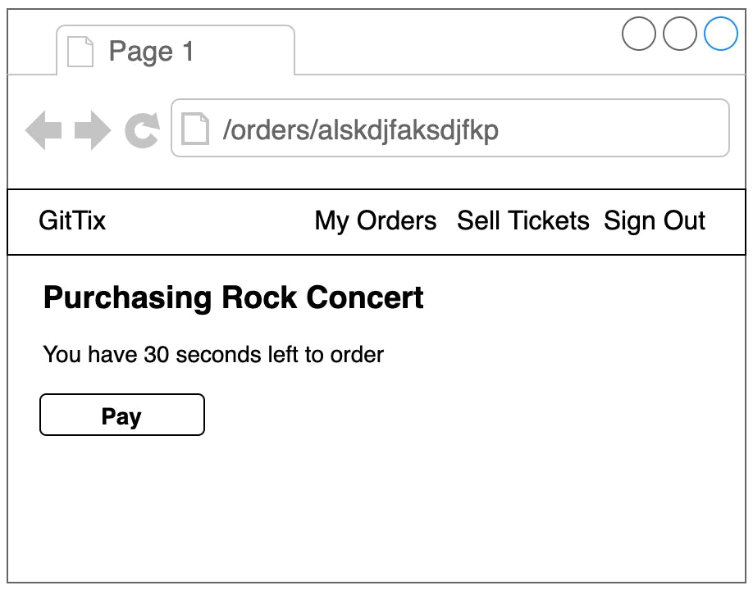

Ticketing App | 6

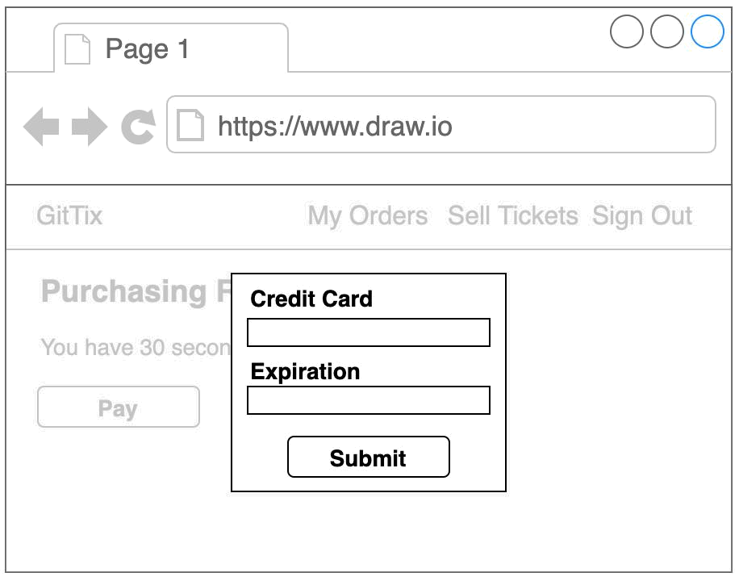

Ticketing App | 7

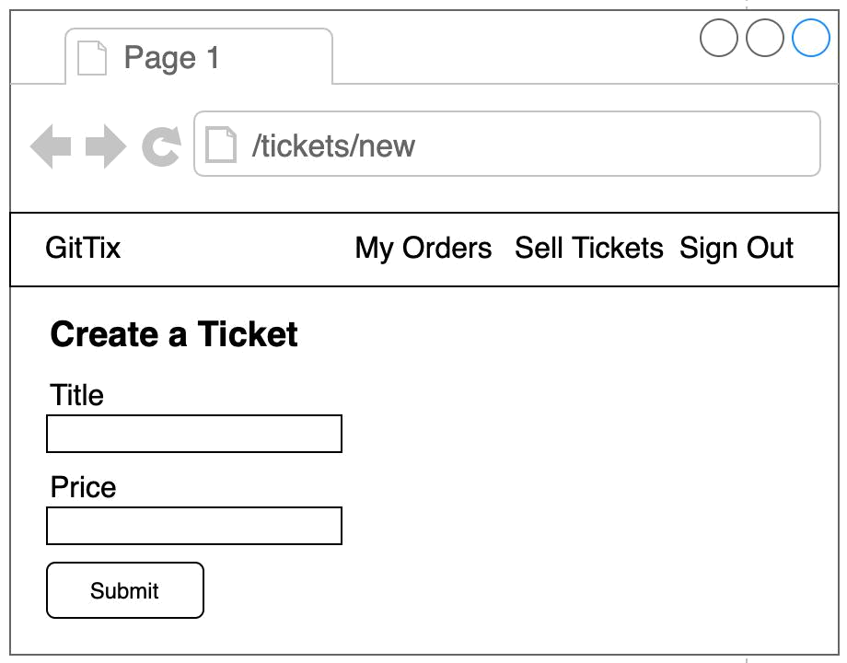

Resources

Ticketing App 8

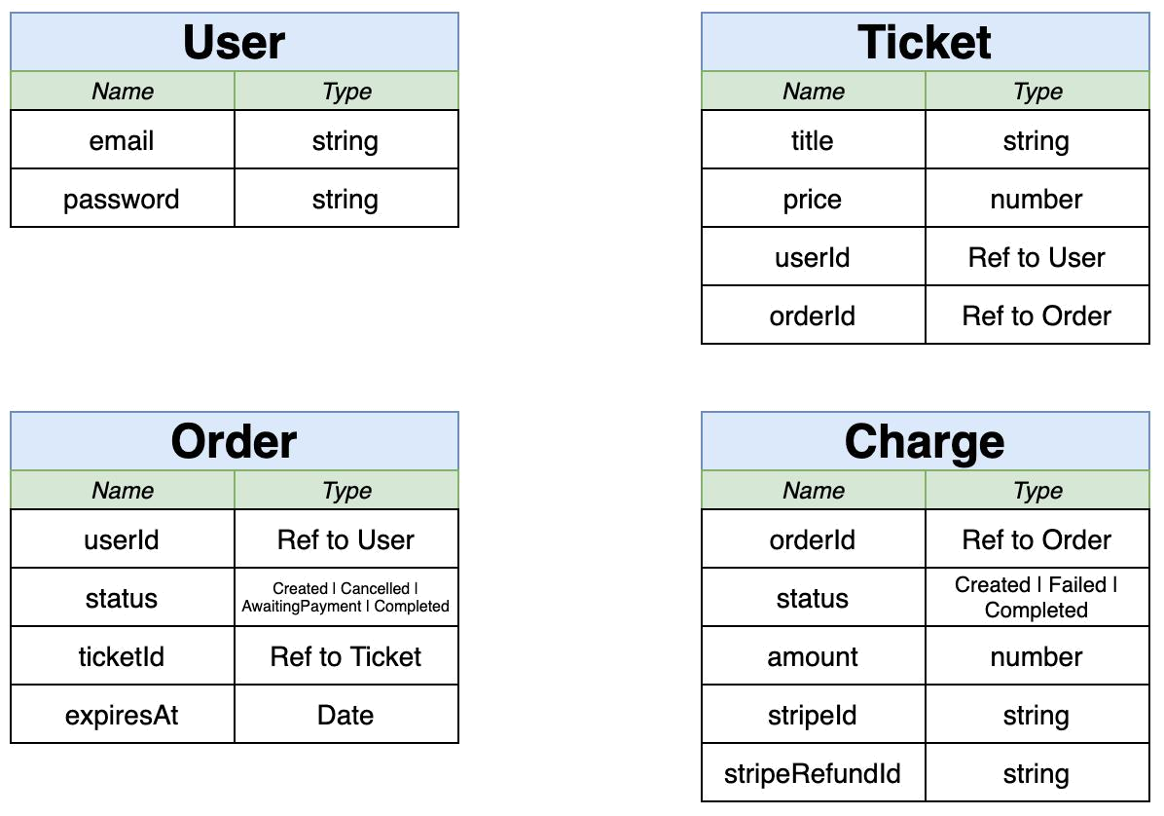

Micro Services

Ticketing App 9

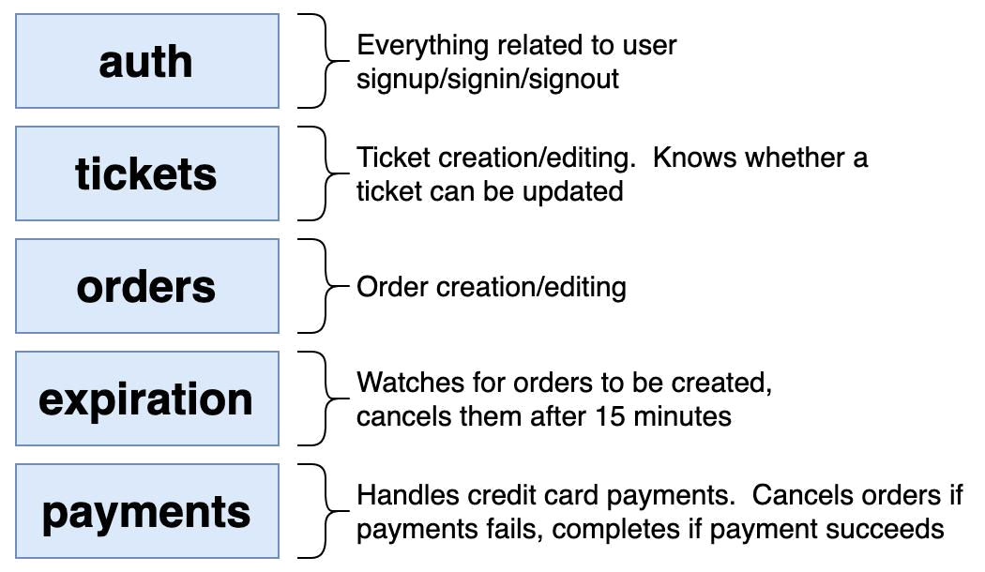

Flow diagram

Web Browser
auth
tickets module
orders module
payments module
expiration module

Spring MVC Server
Spring Web MVC controller modules
MySQL/Mongo/redis/any other db

Ticketing App 10

Application Events
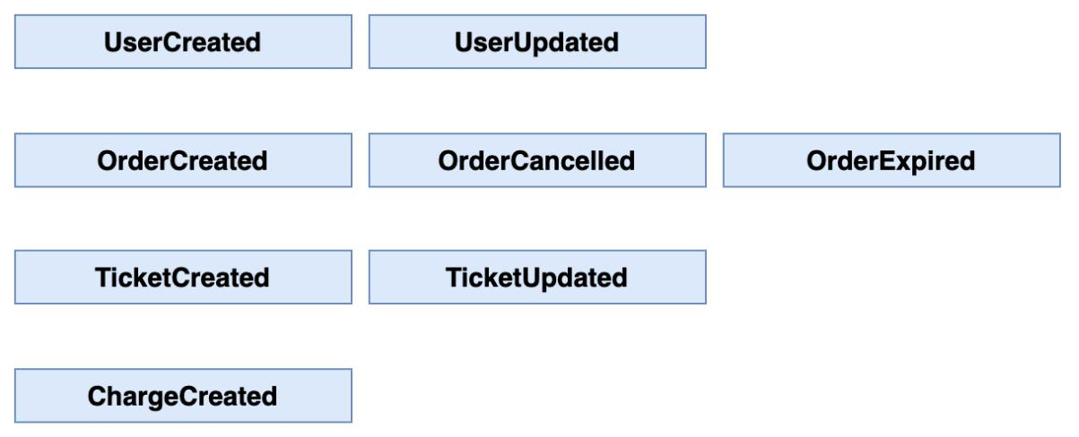

a. Auth Service
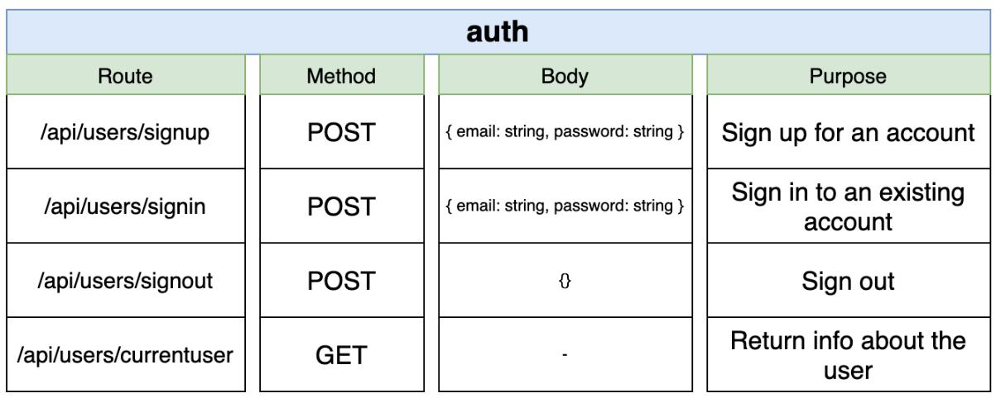

Ticketing App 11

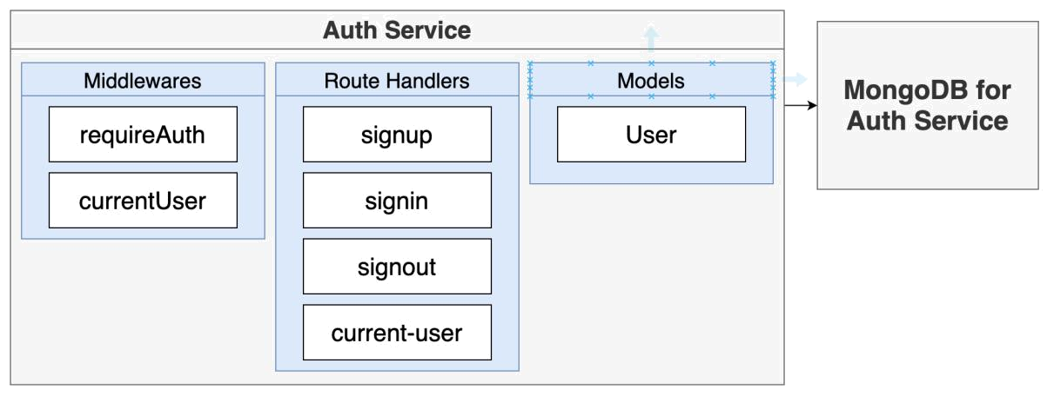

b. Ticketing Service
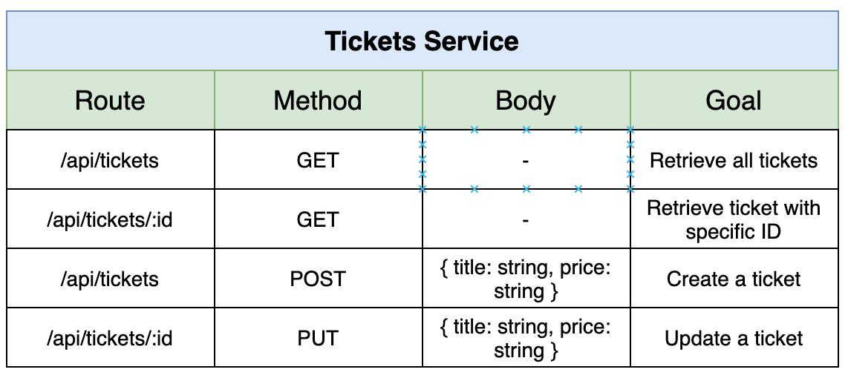

c. Order Service

Ticketing App 12

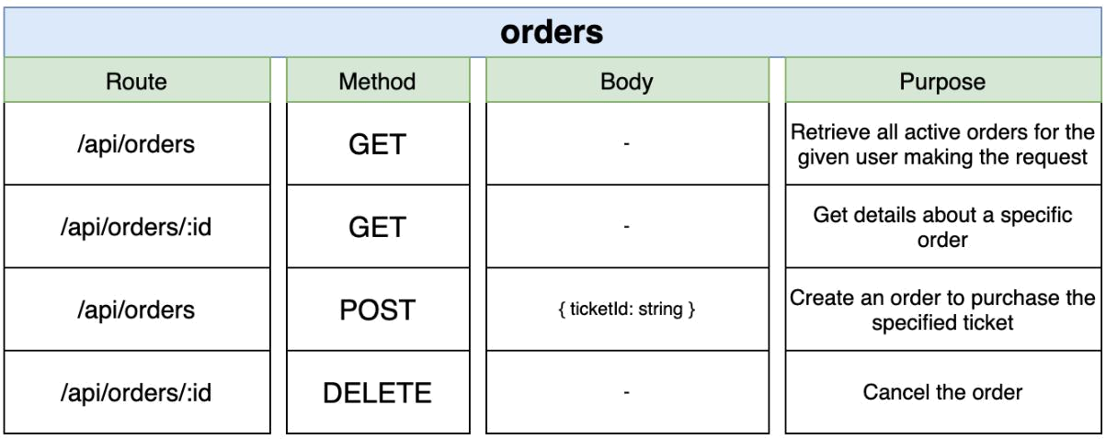

d. Expiration Service
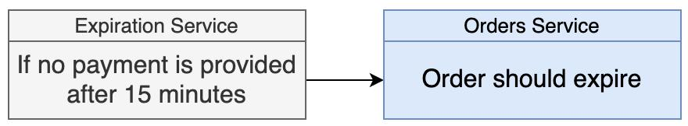

Things to consider and implement in this Ticketing App

- Implement entire application by following java naming and coding standards
- Standard package structure must be followed
- You Can use either JSP/Thymeleaf or any other view engines in Spring MVC
- Entire code should be developed using annotation based configuration only
- Form validations should be implemented
- Use properties files to give label names and validation messages
Keep complete code on github repository with branches if applicable
Implement CI & CI pipeline if applicable using Dev Ops
Build as docker images and deploy on k8s platform using Local cluster if applicable

Ticketing App | 14

